# Information Visualization

# CHECKPOINT III: Visualization Sketch

# G17-A

**1. Overview**

The visualization we conceived is made up of five different idioms, allowing the user to explore the data related to how the weather conditions influences the music people stream on Spotify.

The main idiom, which takes up half of the visualization, is a choropleth map, where the user can explore the different countries where Spotify is available in. When clicking in a country, it allows to see the top 50 songs of a given day on that country. It allows also to see the weather conditions of that given day in that given country, and, if a user wants to, he can add that country to the other visualization idioms on the right, which all are updated as the user adds or changes the selected countries or dates.

On the world map idiom, there are three distinct checkboxes — one to select the countries, another to select or remove a date (or a range of dates), and another to select the songs to compare. This allows the user to compare what he wants on the idioms on the right of the visualization.

There are two line charts — one that compares the total number of streams on given countries, on given dates; and another that compares how selected songs perform streaming-wise on the selected countries, on given dates. On both line charts, the user can choose to show or hide the lines and can also hover on one line to show the weather conditions of that country, on that day. This allows to see how the weather influences the amount of music people listen (in case of the first line chart) and influences the streaming of given songs on selected countries (in case of the second line chart).

Following this, we have a sunburst chart which allows to analyse the most listened songs by weather condition, in the countries selected. If the user wants to analyse in detail specifically a given country or weather condition, he can click on a attribute to increase its detail and show more information. This sunburst allows to see how the weather conditions of a given country influence its song ranking,

Finally, there is a word cloud which shows the most listened artists on the countries and dates selected. By hovering on each artist, the user can see how many streams were made in the countries and dates selected.

There’s also a mini-player on the top bar of the visualization, which allows the user to play a song or artist, while he is using the visualization.

**2. Visual Encoding**

The diagrams we chose encode the following information:

* Choropleth map
  + The countries Spotify is available in are given by the colors on the map;
  + The countries selected by a user are given by a different and contrast color;
* Line chart 1 (total number of streams)
  + **The number of streams** is given by the height in relation to the left axis;
  + **The dates** are given by the bottom axis;
  + **The number of streams of a country on a day** is given by a dot;
  + **The difference between streams** is given by each line.
* Line chart 2 (number of streams of each song)
  + **The songs and its number of streams** is given by the height in relation to the left axis;
  + **The dates** are given by the bottom axis;
  + **The number of streams of a given song on a country and day** is given by a dot;
  + **The difference between streams** is given by each line.
* Sunburst
  + **The countries selected** are given in the first ring;
  + **The weather conditions and its combinations** are given on the second ring;
  + **The song and artist information** are given on the third ring with a different colour tone;
  + **The total number of streams** is given on the centre of the sunburst;
  + **The given data of each country** is given by one different colour tone;
  + **The given data of each weather condition** is given by one different colour tone;
* Word cloud
  + **The number of streams of the artist** is given by its size.

**3. Idiom and Tasks/Questions**

**Uma imagem com texto, mapa

Choropleth map**

**Discover the most listened songs** on a given day, on a given country, by clicking in each country

**Uma imagem com texto

Analyse the weather conditions** on a given day, on a given country, by clicking in each country

**Compare two or more countries** by selecting each desired country

**Identify the countries with more streams** by analysing the colour on each country

**Uma imagem com texto, mapa

Uma imagem com texto, mapa

**

**Line chart 2**

**Identify how songs perform by country** by analyzing the lines with the same color

**Compare the streaming numbers of multiple countries by day** the line behavior

**Analyze how weather conditions influence the number of streams** by hovering on the dots

**Line chart 1**

**Identify the countries with more streams** by analyzing the highest line on the graph

**Compare the streaming numbers of multiple countries by day** the line behavior

**Analyze how weather conditions influence the number of streams** by hovering on the dots

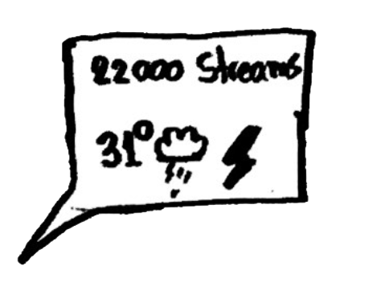

**Uma imagem com texto, mapa

Uma imagem com texto, mapa

Uma imagem com texto, mapa

**

**Word Cloud**

**Identify the most streamed artists** by comparing the sizes of different words in the cloud and locating the largest ones

**Identify how many streams an artist had** by hovering in its name

**Sunburst**

**Analyze how weather conditions influence the song ranking** by analyzing the 2nd and 3rd ring

**Identify the number of streams** by looking at the center of the ring

**Discover the most listened songs given a weather condition** by clicking in the desired weather conditionUma imagem com texto

Uma imagem com texto

